Peraturan Catur 50th POP
- Setiap peserta harus menyelesaikan seluruh pertandingan sesuai dengan jadwal yang ditetapkan yaitu 90 menit, jika melewati batas waktu yg ditentukan, maka permainan diselesaikan dengan menghitung poin dari pion yg tersisa.
- Selama pertandingan berlangsung, peserta tidak diperkenankan merokok..
- Peserta diwajibkan menjaga ketertiban, kebersihan, dan keamanan di lingkungan pertandingan.
- Peraturan yang dipergunakan adalah peraturan FIDE yang dikeluarkan PERCASI pada tahun 1997.( lampiran)
- Langkah tidak sah (illegal move) dianggap selesai dilakukan kalau jam catur lawan sudah dijalankan. Namun lawannya berhak menuntut menang sebelum melakukan langkahnya sendiri. Kalau lawannya ini tidak bisa me-mat-kan pemain (yang telah melakukan langkah tidak sah) itu dengan rangkaian langkah-langkah yang sah, walau dengan perlawanan yang sangat tidak ahli, maka dia berhak menuntut remis sebelum dia membuat/menjalankan langkahnya. Jika seorang pemain sudah keburu melakukan/menjalankan langkahnya, maka langkah tidak sah tadi tidak bisa lagi diperbaiki.
- Jika seorang pemain lalai memindahkan Raja-nya yang berada dalam posisi skak (atau terjadi open-skak), maka pemain itu kalah. Namun lawannya tidak diperkenankan melakukan pemukulan terhadap Raja tersebut, cukup menunjukkan pada pemain yang lalai bahwa Raja-nya terkena ancaman skak. Bila dilakukan pemukulan terhadap Raja lawan, maka pemain yang melakukan pemukulan tersebut dinyatakan kalah.
- Pemain yang merobohkan satu atau beberapa buah catur harus menyusun kembali buah catur tersebut sementara jam caturnya tetap jalan.

Permainan dilangsungkan di atas papan yang terdiri dari 8 lajur dan 8 baris kotak/petak berwarna hitam dan putih (atau terang dan gelap) secara berselang seling. Permainan dimulai dengan 16 buah pada masing-masing pihak, yang disusun berbaris secara khusus pada masing-masing sisi papan catur secara berhadap-hadapan. Satu buah hanya bisa menempati satu petak. Pada bagian terdepan masing-masing barisan - terdapat 8 pion, diikuti di belakangnya dua benteng, dua kuda, dua gajah, satu menteri, serta satu raja.
Sebelum bertanding, pecatur memilih warna buah yang akan ia mainkan. Pemegang buah putih memulai langkah pertama, yang selanjutnya diikuti oleh pemegang buah hitam secara bergantian. Tujuan permainan adalah mencapai posisi skak mat. Hal ini bisa terjadi bila Raja terancam dan tidak bisa menyelamatkan diri ke petak lain. Tidak selalu permainan berakhir dengan kekalahan, karena bisa terjadi pula peristiwa seri atau remis di mana kedua belah pihak tidak mampu lagi meneruskan pertandingan karena tidak bisa mencapai skak mat. Peristiwa remis ini bisa terjadi berdasarkan kesepakatan maupun tidak. Salah satu contoh remis yang tidak berdasarkan kesepakatan - tetapi terjadi adalah pada keadaan remis abadi. Keadaan remis yang lain adalah keadaan pat, dimana yang giliran melangkah tidak bisa melangkahkan buah apapun termasuk Raja, tetapi tidak dalam keadaan terancam skak. Dalam pertandingan catur pihak yang menang biasanya mendapatkan nilai 1, yang kalah 0, sedang draw 0.5.

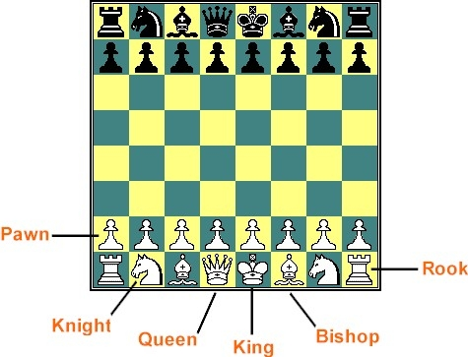

How the Chess Pieces Move
Now that you have the chessboard setup with each piece sitting on its correct square, you need to know the chess rules of how each chess piece moves. The following are diagrams and instructions for the move of each chess piece.

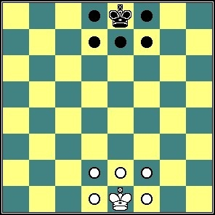 | Chess piece - King  Having a king is mandatory even though he's pretty much worthless and really nothing more than a mere figure-head. But that's the rule of chess, like it or not, you have to have a king. The king is always the tallest piece on the chessboard and the king chess piece will usually have a cross-like object on top. By the rules of chess, his moves are pretty limited, he can only move one square at a time but he can move forward, backward, left, right and diagonally. Not to offer any particular strategy, but keep him safe and well protected!

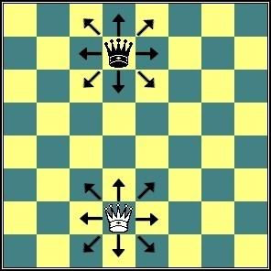 | Chess piece - Queen  Unlike the king, the queen is no figure-head. She's the most powerful chess piece you have on the chessboard. The queen usually looks like a queen in the sense that she'll have a crown, sometimes with nice sharp points. According to the rules of playing chess, she can move vertically, horizontally, and diagonally just as many squares she wants (without jumping other chess pieces). So you'll want to be careful and not give her up too carelessly or without a steep price to your opponent.

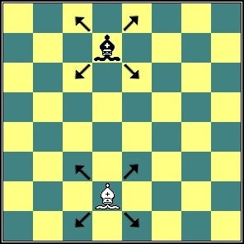 | Chess piece -Bishop  The bishop, well, I guess you could say the top of the chess piece looks sort of like a bishop hat. Most bishops also have a cut near the top resembling that of a mouth. There are two bishops, always one on a light square and one on a dark square. Chess rules say that bishops move just like the queen except they can't move forward, backward, left or right. Diagonally only just as many spaces as desired without jumping another chess piece. Because bishops move diagonally, they will always remain on their original square color as per the rules of chess. So if in the middle of a chess game you notice either your opponent or your bishops are on the same color square - something's gone very wrong.

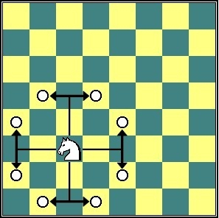 | Chess piece - Knight  The knight is the most unique chess piece you have! Not only does it usually resemble a horse, it is the only chess piece that can jump over another chess piece or pieces according to chess rules. The knight's move is rather different. Think of the move as "L" shaped - two squares either forward, backward, left, or right and then left or right one square. This special feature, being able to jump, can make the knight a very useful chess piece early in the game.

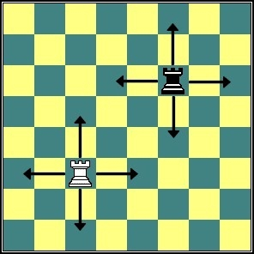 | Chess piece - Rook  The rook is also called the castle by some and it actually looks like a castle or at least a castle tower. The rook, as per chess rules, moves just like the queen except it can't move diagonally. Just forward, backward, left, and right but as many spaces as desired without jumping other chess pieces.

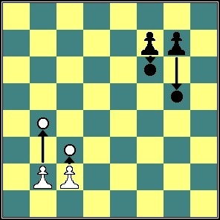 | Chess piece - Pawn  The poor little pawns are put out in front right in harms way while the other guys are hiding back behind. As per the rules of playing chess, they're expected to advance out in front and take the brunt of an oncoming attack or serve as a shield. It seems rather unfair considering they're pretty defenseless. These chess piece are allowed to only move one square at at time by the rules of chess. However, in thier first move, they can move two squares if they want. They can only move straight forward - no retreating for these soldiers according of the chess rules. And they can only capture one of the enemy by approaching diagonally. But, according t the chess rules, if one of these brave little soldiers can make it to the other side, they are rewarded with a promotion - to a queen! Some promotion that is!

Chess Board Notation
Those that take chess pretty seriously, actually keep track of all their moves and record entire games. In order to record moves, someone came up with the smart idea of labeling the columns with letters and the rows with numbers, thus each square is uniquely identified. As you can see, white has a tremendous advantage because he or she doesn't have to look at upside-down numbers and read the alphabet backwards. One of the more important reasons to be the white or light chess players side.
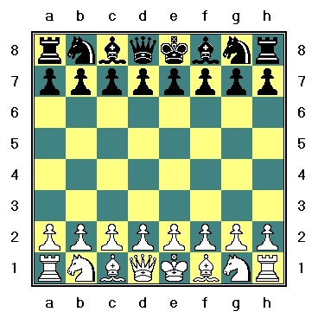

Castling
Castling can be a very effective strategy in the defense of your king and providing a safe-haven for him. The act of "castling" involves two chess pieces, the rook and king and there are two different ways to castle. Rather than trying to describe the two methods (which might get confusing), we'll rely on the diagrams below to guide you through the correct moves. Now, there are special rules of chess and conditions that must exist in order to castle. The special conditions are:
- Neither of the chess pieces involved, your king or rook that is being castled, have been moved during the chess game.
- There are no other chess pieces between the king and the rook involved in the castling.
- Your king is not in check and neither your king or rook can be taken by your opponent's next move after castling.
You can castle with either of the rooks as long as these special conditions are met. The moves involved in castling with the Queen side rook are different than castling with king side rook. This is quite natural given that there 2 spaces between the king and rook on the king side and respectively 3 spaces on the queen side. Do not forget that just prior to castling you must stand up and announce to your opponent in a rather loud and noble-like voice "MY KING SHALL CASTLE", followed by a slight bow before sitting. This chess rule is often overlooked and ignored but you'll impress your opponent and on-watchers with your respect for the tradition of the game of chess. Below are diagrams showing both methods of castling:

King Side Castling (white)
Before  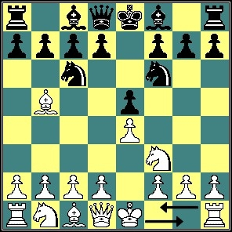 | After Castling  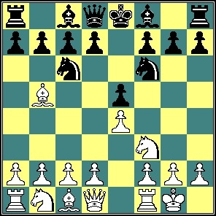

Queen Side Castling (white)
Before  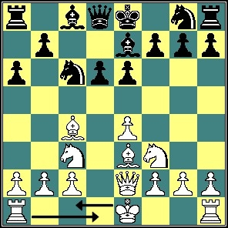 | After Castling  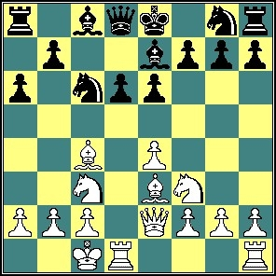

En Passant
There is a unique chess rule which involves a special move in chess that many casual players are not aware of, the rule is called "en passant". This move involves only pawns and the situation for en passant may or may not occur during a game. But if it does, it's good to know the rule and how to execute the move properly. En passant is limited to a pawn moving from it's original position 2 squares landing adjacent to an opponents pawn. On the very next move and only the next move, this pawn can be captured as illustrated below:
White's Move | Black's Move | After Capture
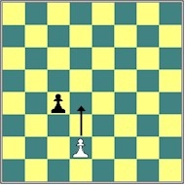 | 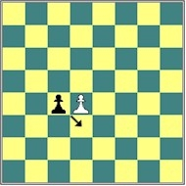 | 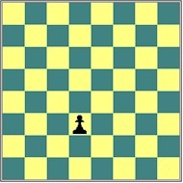

All pawns of both sides are subject to the en passant rule of chess.

Promotion
We have already mentioned promotion of the pawn, but lets review exactly how this happens and what your options are. Promotion occurs when you get a pawn clear across to the other side. In the same move of the pawn reaches a far square, you remove the pawn and replace it with any chess piece you want, that is, except a second king. Even if you already have all of your chess pieces. For example, most people naturally choose a queen. So you can have two queens, and that's quite an advantage. But you can choose some other chess piece if you prefer, it's entirely up to you. Here are a couple of diagrams to illustrate just how promotion works:
Before  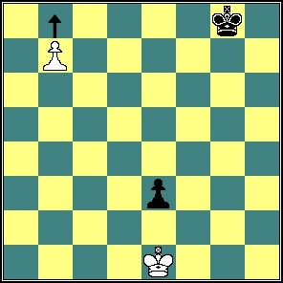 | Promotion  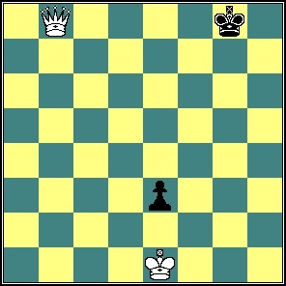

Let's Play
Now that you have the chess board all setup, you know how each chess piece moves along with the special chess rules, lets get the game underway. White always moves first and most players prefer to be white because you can achieve a slight advantage by moving first. So what we recommend is you have a best out of three "rock-scissors-paper" to determine who keeps to be white. Or, if you prefer, you can cast lots by putting a different color pawn in each hand and then letting your friend choose one. From this point on, it's real easy, white makes the first move and then you just take turns moving chess pieces and trying to checkmate your opponent's king while taking as many chess pieces as you can along the way. But before that first move, there's a few more rules that we better go over.

Don't Let Go (until you're sure)!
This is a very important chess rule, when you move your chess piece and let go, you're beyond the point of no return. The move is final. Now, if you move it to a square and keep your finger on top while pondering the genius or folly of the move, it's okay to backtrack and decide on a different move. So be certain about your move before you let go!

Check
You know what checkmate or mate is, but we haven't yet explained the baby brother of checkmate called check. When a king has been attacked and can be taken on the next move but can escape, it is called check. Just like when you announced you were going to castle, it's also considered good manners to tell your opponent he's in check "CHECK". Standing up for the announcement is optional.

The Ending
You know about checkmate, which ends the game, but there are three other possible endings to a game. One possibility is a stalemate or draw, meaning that with the given pieces left on the board, neither player can win. For example, a king against a king. There are no winning possibilities for either side in this situation. Another possible outcome is for one player to resign. A game can become so one-sided (both remaining pieces and position) that the advantage is too great for the other player to overcome. When this happens, the disadvantaged player can simply call "uncle" and give it up. But don't give up too easy, mistakes can always be made. The third possibility is a draw, even though a checkmate is possible.
X. KONTROL WAKTU
Pertandingan Catur Standar menggunakan Jam Catur Digital dengan kontrol waktu 90 menit sampai dengan selesai plus increment (tambahan waktu) 30 detik setiap langkah dimulai sejak langkah pertama. Pertandingan Catur Cepat dan Catur Kilat akan ditentukan pada saat technical meeting.

